Board Approval Request: Reconstructed Financial Balances and Reconciliation to April 2026 Financial Reports

Purpose
The purpose of this report is to request Board approval of the reconstructed expense and reserve balances as of December 31, 2025, and to document the successful reconciliation of those balances to Sunstate HOA Management Company's April 2026 financial reports.
The reconstruction and reconciliation efforts were undertaken to establish an accurate financial baseline for the Association during the transition from Keys Caldwell to Sunstate HOA Management Company. The results have been reviewed and validated by the Patios Treasurer and Sunstate's Accounting Department and will be discussed with both the Board of Directors and the community during our next board meeting.

Executive Summary
The Association undertook a comprehensive reconstruction of its December 31, 2025 operating and reserve financial balances. The effort became necessary after significant discrepancies were discovered within the December 2025 financial reports generated during Keys Caldwell's accounting-system conversion.
Using historical records, archived reports, supporting documentation, and extensive review by Sunstate's Accounting Department, reconstructed year-end balances were developed for both operating and reserve accounts. These balances were subsequently used as the official baseline for reconciling the Association's financial position into Sunstate's accounting system.
The reconciliation effort successfully demonstrated agreement between the reconstructed balances and Sunstate's April 2026 beginning balances. Only two minor operating-account variances remain for administrative follow-up and are not considered material to the overall reconciliation.
Additionally, approximately $14,000 of reserve interest from 2024, 2025, and 2026 was identified as not having been properly reflected in reserve account reporting and has now been incorporated into the reserve-interest account balance.

Section 1

Reconstruction of December 31, 2025 Financial Balances

Background
In December 2025, Keys Caldwell notified the Association that it would migrate to a new HOA management system effective January 1, 2026.
Although the conversion occurred on schedule, the December 2025 financial statements contained numerous discrepancies, including:
- Invoices that should have been recorded and paid during 2025 but remained outstanding.
- Invoices reflected as payable in 2026 despite having already been paid during 2025.
- Reserve balances that did not appear to be reconciled to supporting records.
- Other operating and reserve account inconsistencies identified during review.
After numerous errors were documented and communicated to Keys Caldwell, the Board determined that confidence in the year-end financial reporting had been compromised. Subsequently, the Board approved transitioning management services to Sunstate HOA Management Company with a targeted implementation date of April 1, 2026.

Reconstruction Methodology
To establish an accurate financial baseline, the Patios Treasurer worked directly with Sunstate's Accounting Department to reconstruct the Association's expense and reserve financial positions as of December 31, 2025.
The reconstruction process included:
- Reviewing archived financial records dating back to December 2023.
- Analyzing operating and reserve account activity.
- Identifying and correcting misclassified and missing transactions.
- Evaluating unpaid invoices and duplicate postings.
- Verifying reserve contributions and reserve-interest transactions.
- Developing reconciled operating and reserve balances independent of the December 2025 Keys Caldwell reports.
The reconstruction methodology and findings were presented to both the community and the Board during meetings conducted in the first quarter of 2026. Feedback received during those presentations was incorporated into the final reconstructed financial position.

Key Findings
The reconstruction effort revealed that approximately $14,000 in reserve interest had not been properly reflected in reserve-account reporting spanning 2024 through 2026.
As a result of the reconstruction process:
- Accurate operating-account balances were established.
- Accurate reserve-account balances were established.
- Missing reserve interest was identified and properly recorded.
- The reconstructed financial position became the official baseline for all subsequent reconciliation efforts associated with the transition to Sunstate.
The Treasurer, Board of Directors, community members, and Sunstate Accounting Department extensively reviewed the reconstructed balances before completion of the reconciliation effort.

Section 2

Reconciliation to Sunstate April 2026 Financial Reports

Background
The transition to Sunstate HOA Management Company was successfully completed with an April 1, 2026 implementation date.
Once the conversion was completed, the Association's primary objective became verification that Sunstate's beginning balances accurately reflected the reconstructed December 31, 2025 financial position.

Reconciliation Approach
The reconciliation process utilized:
- The reconstructed December 31, 2025 operating balances.
- The reconstructed December 31, 2025 reserve balances.
- January through March 2026 expense activity.
- General Ledger Trial Balance reports covering January through March 2026.
- Sunstate's April 2026 financial statements and supporting balance-sheet information.
During this effort, Sunstate Accounting personnel independently reviewed and verified balance-sheet information and performed additional reconstruction work where necessary to ensure financial accuracy.
Errors identified during the December 2025 reconstruction process were incorporated as corrections within Sunstate's accounting records and financial reporting.

Expense Reconciliation Results
The operating-account reconciliation compared:
- Reconstructed December 31, 2025 balances,
- January through March 2026 approved expenditures, and
- Sunstate's April 2026 beginning balances.
The reconciliation was successfully completed and demonstrated agreement across all significant operating-account categories.
Two minor variances remain:
Account | Variance
General Maintenance | $0.10
Clubhouse Cleaning | $34.12
These variances are immaterial to the overall reconciliation and will be reviewed with Sunstate for final resolution.

Reserve Reconciliation Results
The reserve-account reconciliation compared the reconstructed reserve balances to Sunstate's April 2026 reserve balances.
The reconciliation demonstrated that Sunstate's beginning reserve balances matched the reconstructed reserve balances developed during the reconstruction initiative.
This result provides reasonable assurance that reserve balances were successfully transferred into Sunstate's accounting system and that reserve reporting is based upon the corrected year-end financial position.

Conclusion
The reconstruction of the December 31, 2025 operating and reserve financial balances and the subsequent reconciliation to Sunstate's April 2026 financial reports have been completed successfully.
The reconstruction effort corrected numerous reporting discrepancies, established an accurate financial baseline for the Association, identified approximately $14,000 in previously unrecorded reserve interest, and provided a verified foundation for financial reporting under Sunstate HOA Management Company.
The reconciliation results demonstrate that Sunstate's beginning balances accurately reflect the reconstructed financial position of the Association, with only two minor operating-account variances remaining for administrative follow-up.
Continued oversight and periodic review will be performed by both the Board of Directors and Sunstate's Accounting Department to ensure ongoing financial accuracy and transparency.

Board Approval Request
The reconstructed expense and reserve balances as of December 31, 2025, together with the reconciliation to Sunstate's April 2026 financial reports, have been reviewed by the Patios Treasurer and Sunstate HOA Management Company's Accounting Department.
Based upon the completed reconstruction, validation, and reconciliation efforts described in this report, the Treasurer recommends that the Board of Directors:
- Approve the reconstructed December 31, 2025 operating-fund balances.
- Approve the reconstructed December 31, 2025 reserve-fund balances.
- Adopt these balances as the Association's official financial baseline for the Sunstate conversion.
- Acknowledge the satisfactory reconciliation of these balances to Sunstate's April 2026 financial reports.
- Authorize continued monitoring and resolution of the two minor outstanding operating-account variances.

APPENDIX A

Reconstructed December 31, 2025 Operating Balances

Exhibit A-1

Patios Reconstructed Expense Balance Report
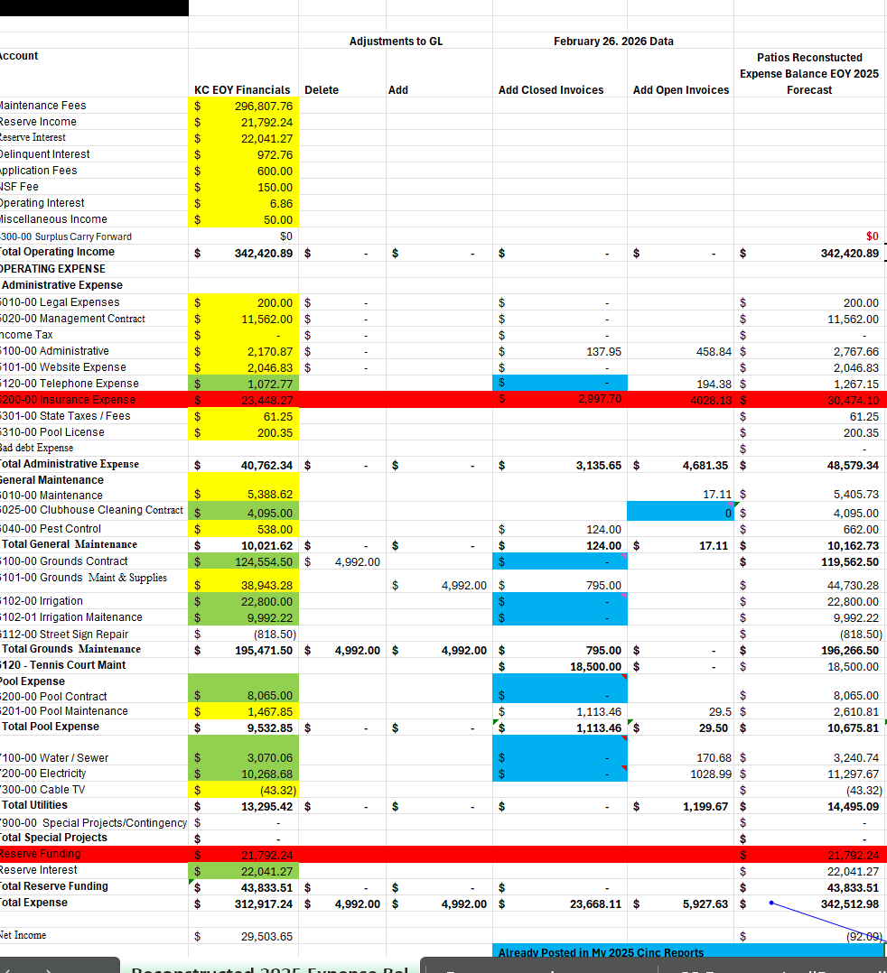Narrative Description
Exhibit A-1 presents the reconstructed operating-fund balances as of December 31, 2025. The schedule reflects the identification and correction of accounting discrepancies, adjustment of invoice postings, and verification of operating expenses required to establish an accurate year-end operating position.
These balances served as the foundation for all subsequent operating-account reconciliation activities.

APPENDIX B

Reconstructed December 31, 2025 Reserve Balances

Exhibit B-1

Patios Reconstructed Reserve Balance Report
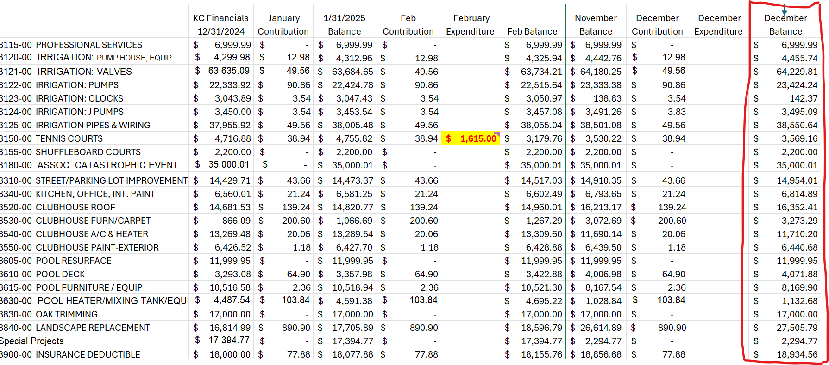Narrative Description
Exhibit B-1 presents the reconstructed reserve-account balances as of December 31, 2025. The reconstruction was developed using archived financial records and reserve-account activity dating back to December 2023.
The schedule reflects corrected reserve balances and incorporates reserve-interest adjustments identified during the reconstruction initiative.

APPENDIX C

Operating Account Reconciliation

Exhibit C-1

April 2026 Expense Reconciliation
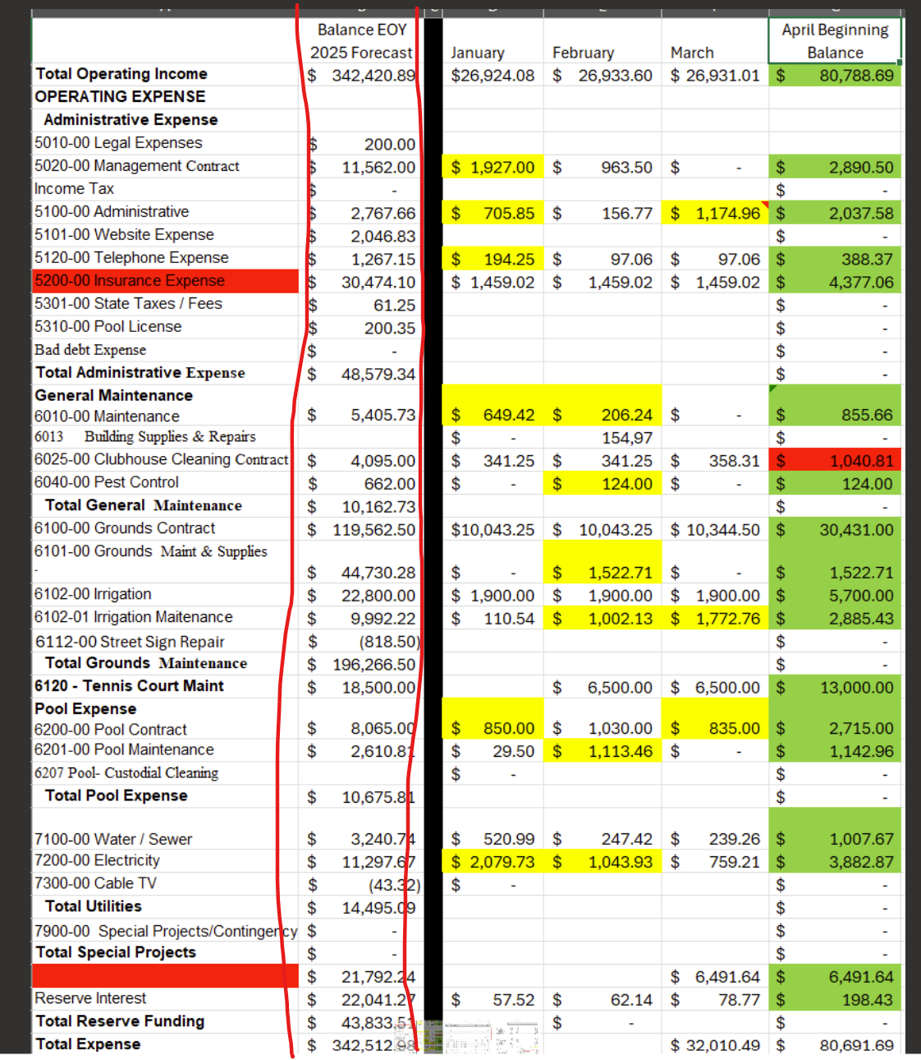Narrative Description
Exhibit C-1 demonstrates the reconciliation between reconstructed December 31, 2025 operating balances and Sunstate's April 2026 beginning balances. The reconciliation incorporates approved expenditures occurring during January through March 2026 and validates the operating-fund conversion into the Sunstate accounting system.
The exhibit identifies the only remaining variances of $0.10 and $34.12 for final review.

Exhibit C-2

January-March 2026 General Ledger Trial Balance
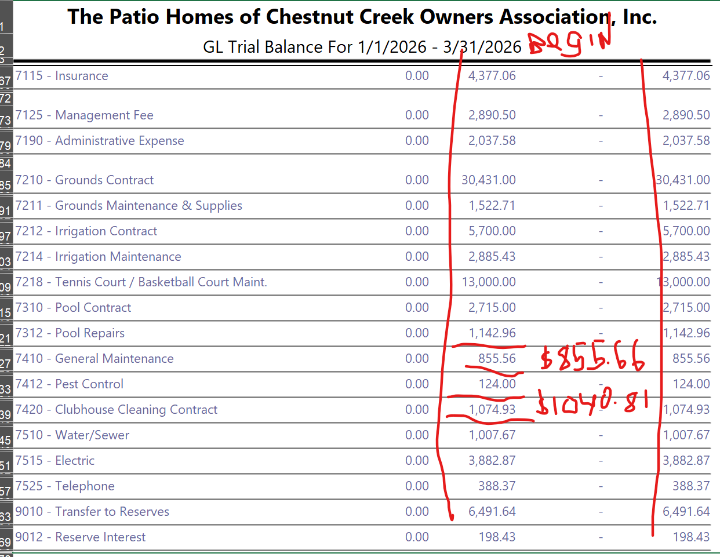Narrative Description
Exhibit C-2 provides supporting General Ledger activity for the January through March 2026 period and documents the transactions utilized during the operating-account reconciliation.

APPENDIX D

Reserve Account Reconciliation

Exhibit D-1

Reconstructed Reserve Report
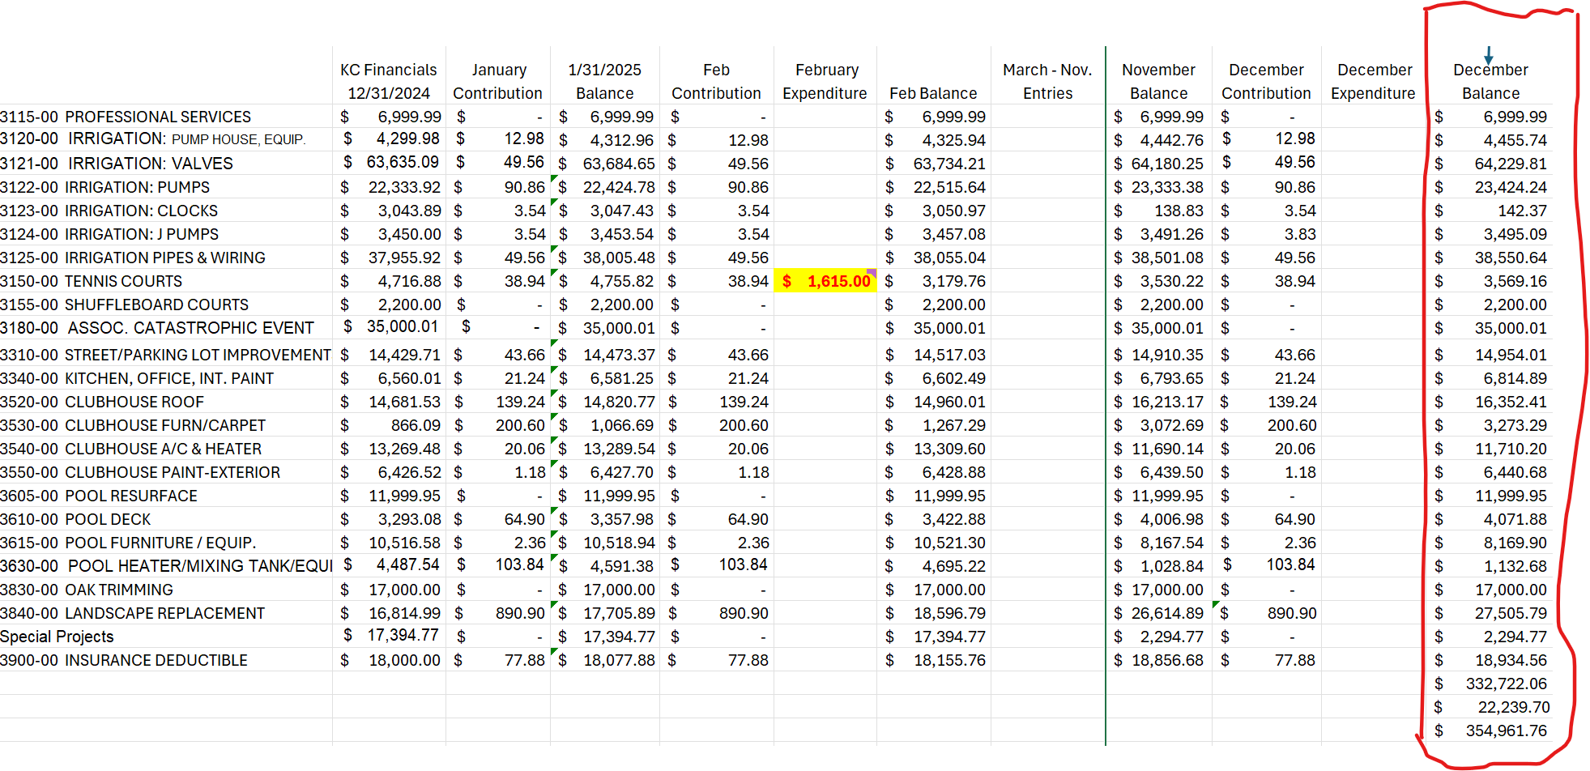Narrative Description
Exhibit D-1 contains the reconstructed reserve-account balances used as the baseline for reserve reconciliation activities.

Exhibit D-2

Sunstate April 2026 Reserve Financial Report
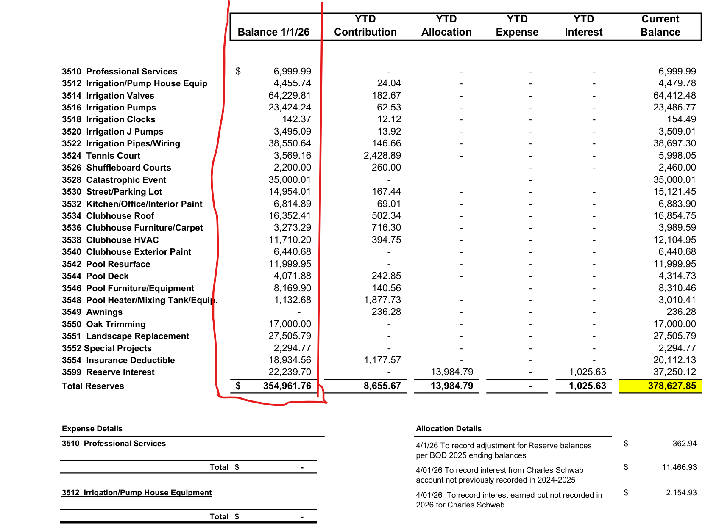Narrative Description
Exhibit D-2 presents Sunstate's reserve balances as reported in the April 2026 financial statements. Comparison of these balances to Exhibit D-1 demonstrates successful transfer and reconciliation of reserve-account balances into the Sunstate accounting system.

